Investigating perceived predation risk on bird foraging behaviour

Olivia Broda (20023404)

Mariam Al-Hadeethi (20010869)

Biology 300

November 13, 2018

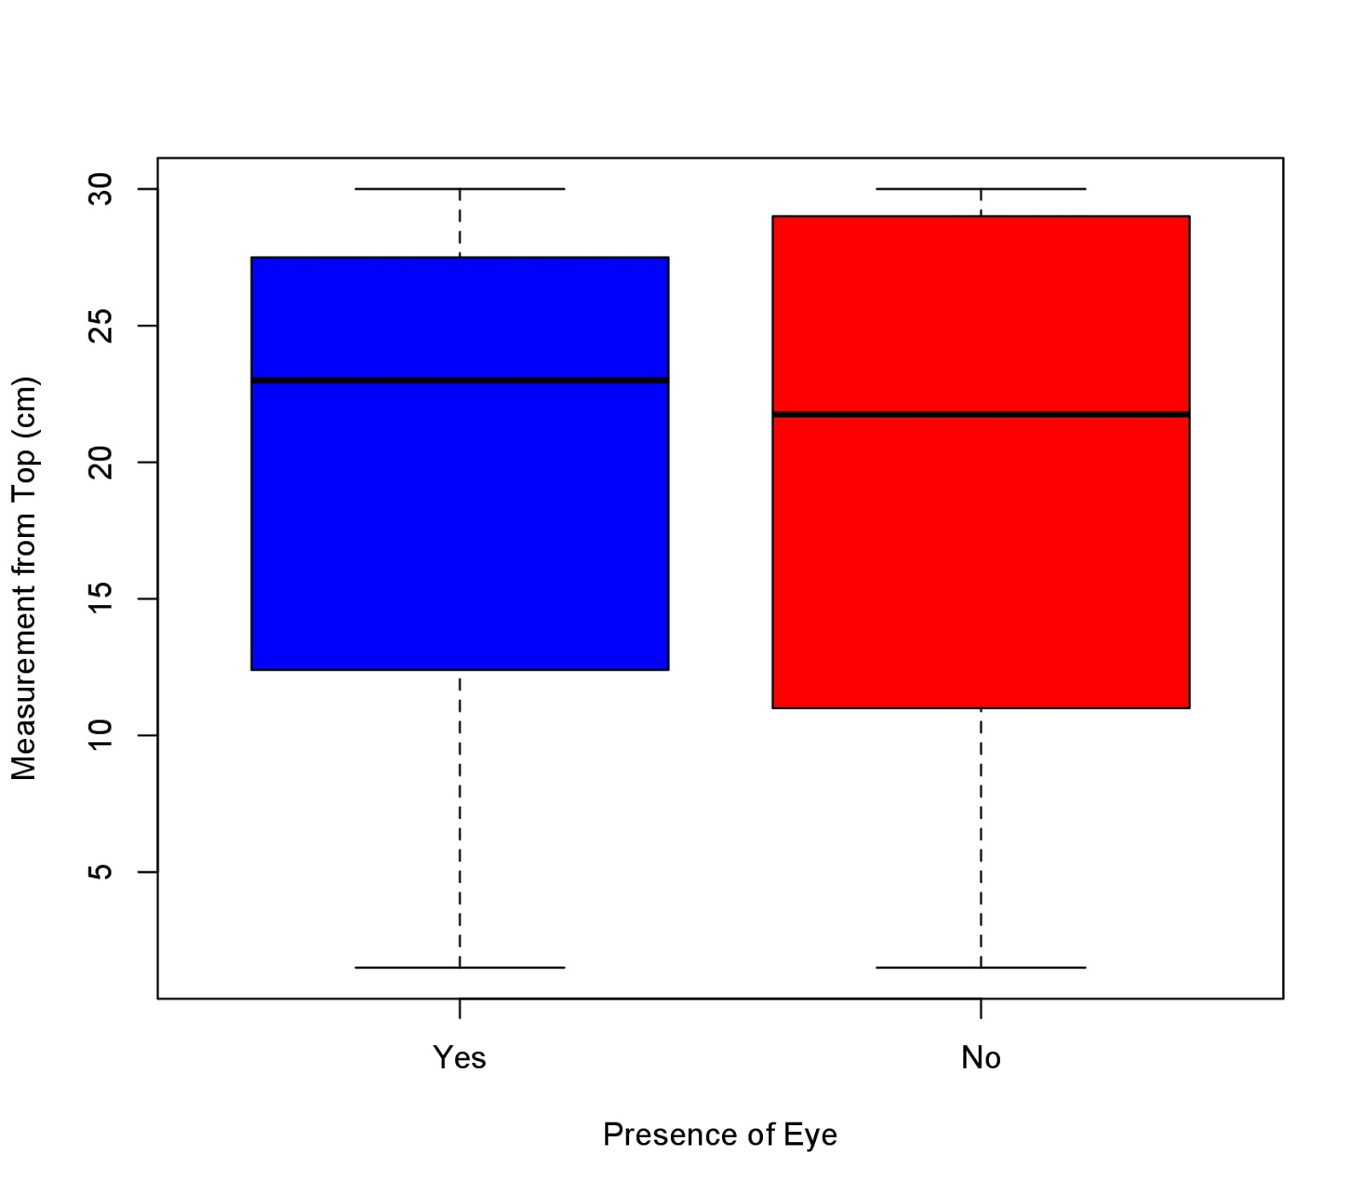

Figure 1. Measurements of the depletion of seeds in centimeters found in bird feeders that had a predator decoy eye compared to bird feeders without a predator decoy eye. The bird feeders that had no predator decoy eye had a higher average number of seeds depleted than the bird feeders with a predator decoy eye (n=53, M=19.44, sd=9.94). The boxplot consists of whiskers underneath the boxes that reflect the minimum values and whiskers at the top of the boxes that reflect the maximum values of the data. The lower portions of the boxes indicate the first quartile, the black line in the middle of the boxes show the median value, and the top portion of the boxes indicate the third quartile

Species are often faced with a challenge when it comes to allocating time and energy into foraging, as many factors influence the associated net energetic return. Net energy return can be defined as the ratio of the amount of usable energy delivered from an energy source to the amount of energy used to obtain that source. This is the basis of optimal foraging theory, an ecological model that predicts the behaviour of an animal when searching for food, in order to maximize their fitness. Optimal foraging theory predicts that an animal will adopt a strategy that provides the most benefit at the lowest cost, thus providing the greatest net energy return. Some factors that influence this model include the energy content of the food source, the handling time and predation risk associated with foraging. The purpose of this study is to analyze the effects of predation risk on bird foraging behaviour in the context of optimal foraging theory. We hypothesize that predation has an influence on the foraging behaviour of birds whereby foraging decreases as perceived predation increases. Therefore, the bird feeder with the artificial “eye” mimicking a predator can be predicted to have more food compared to the bird feeder with no perceived predation.

The following data was collected by Queen’s University students at the Queen’s University Biological Station (QUBS). Two weeks prior to data collection, bird feeders identical to one another in shape and size were placed at approximately the same height above ground in pairs of two, at four variously chosen sites at QUBS. Two of the sites were located along Opinicon Lake, while the other two were not directly next to a body of water. The bird feeders were filled with the same seeds two days prior to data collection, and predator “eyes” were placed on one of the two paired bird feeders. The data collected measured food consumption at each feeder by measuring depletion from the top of the feeder. Some uncontrolled variables include other animals gaining access to the bird feeders, the presence of these other animals at some sites and not others, different species of birds foraging (and thus varying foraging strategies), and different individuals collecting the data. In addition to this, due to weather conditions, some bird feeders were not placed at a fixed distance apart as was intended in the experiment. Considering these is important when interpreting results, as these uncontrolled variables may account for certain trends observed within the data set.

In Figure 1, the boxplot shows the bird feeders with a predator decoy had a larger average measurement of seeds (M=19.79) than the bird feeders without the predator decoy (M=19.08). Using a two-sample t-test, it was found that there was no significant difference between the bird feeders with the predator decoy and the bird feeders without the predator decoy (two-sample t-test, df=50.52, t=0.26, p=0.80).

Although no significant relationship was found between the bird feeders with the predator decoy and bird feeders without, many uncontrolled variables can account for the trends observed in this data set. Such variables include foraging by species other than birds, paired bird feeders intended to be placed at a fixed distance apart coming together, and so on. Foraging by species other than birds may reflect inconsistent patterns as other species employ various optimal foraging strategies and may be riskier than the bird species. In addition to this, bird feeders coming together may skew the data set as birds may have avoided feeders with no perceived predation risk due to the close proximity to the feeders with the predatory “eye”. However, observational data at each site noted that less seeds were depleted in bird feeders found in open areas by cottages, pathways and campfires than the bird feeders found in heavily forested areas. This may reflect a general trend towards foraging at areas with more tree cover as a means by which to avoid predation. In a study done by Schneider (1984), the author explored the relationship between distance from cover and food depletion. It was found that individuals demonstrated a preference for the sites near cover over those in the open areas (Schneider, 1984). Additional observations suggested that cover provides protection from predators and therefore was preferentially selected for when foraging (Schneider, 1984), thus supporting observational findings from this study.

To better analyze the focal question, it would be best to place bird feeders in areas containing similar cover to as to isolate for perceived predation by means of the predator decoy, rather than the tree density of a particular area. The predator decoy should be larger and more distinguished at the bird feeders to better resemble a predator. It would also be important to ensure the bird feeders are at a fixed distance apart and that they are stationary in order to avoid an uncontrolled variable.

The trade-offs between maximizing survival in the presence of predators and obtaining resources for long term survival provide the framework for studying the effects of predation on birds. Studying the economic principles by which prey utilize optimal foraging strategies may allow for understanding the impact of human interactions with wildlife and the perceived risk they pose, making this an important avenue for research. Similar to predation risk, disturbance stimuli may have an indirect effect on fitness whereby it presents energetic costs of risk avoidance even if no direct threat is posed. This can in turn be crucial in studies of species conservation and endangered species.

Works Cited

Schneider, K. J. 1984. Dominance, predation, and optimal foraging in white-throated sparrow

flocks. Ecology 65:1820-1827.