Investigating the variation in bluegill size in two different habitats

Olivia Broda (20023404)

Mariam Al-Hadeethi (20010869)

Biology 300

December 5, 2018

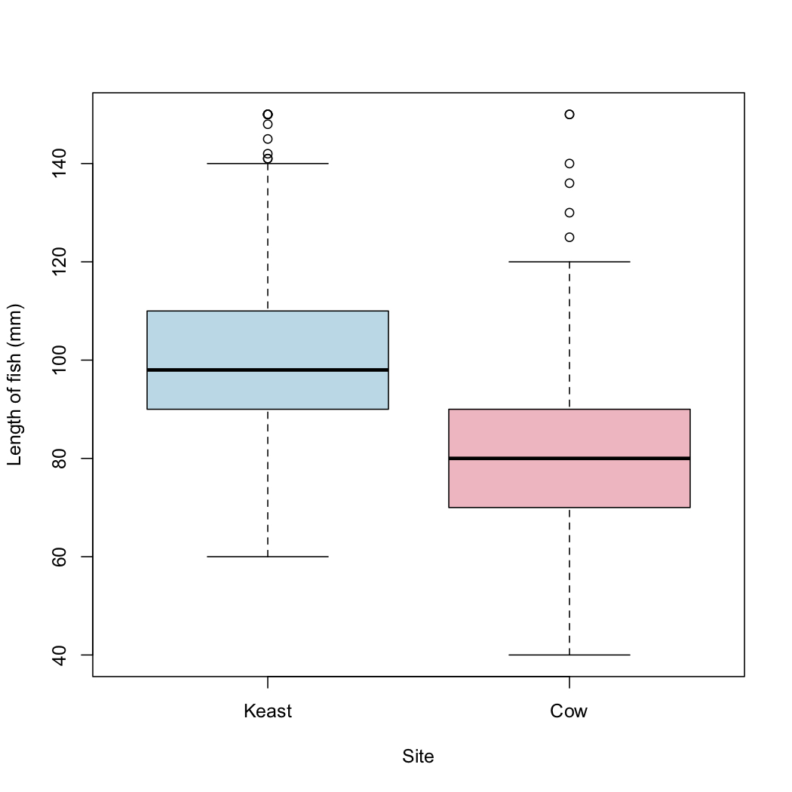

Figure 1. Boxplot showing the bluegill fish lengths at the Keast Beach site in comparison to the bluegill fish lengths at the Cow Island Marsh site. The bluegill fish caught at the Keast Beach site (n=288, M=101.25, sd=17.38) had a higher average length than the bluegill fish caught at the Cow Island Marsh site (n=288, M=81.76, sd=22.04). The boxplot consists of whiskers underneath the boxes that show the minimum values and whiskers at the top of the boxes that show the maximum values of the data. The lower portions of the boxes indicate the first quartile, the black line in the middle of the boxes indicate the median value, and the top portion of the boxes indicate the third quartile.

Specialization to varying environmental conditions is associated with a fitness advantage as it allows species to inhabit a wider range of environments. Thus, environmentally specific production of different phenotypes as a result of varying selective pressures may be observed within a species. Varying phenotypic expression of size, for example, can aid in understanding of species distribution and abundance in a given environment. The purpose of this study is to examine the difference in bluegill size at two different sites at the Queen’s University Biological Station. Our null hypothesis states that there is no significant difference in size at the two different sites. We hypothesize that there is a difference in size between the two different sites, with the Bluegills being larger at Keast Island than Cow Island.

The following data was collected by Queen’s University students at two different sites, Cow Island Marsh and Keast Beach, at the Queen’s University Biological Station. A seine net was taken out approximately 1 m in depth and hauled back towards the shore. Netted fish were then transferred to a holding bucket filled with fresh lake water. Bluegill and pumpkinseed fish caught were then measured using a measuring cradle and the observed lengths of the fish were recorded in millimeters.

In Figure 1, the boxplot shows the bluegill fish collected at the Keast Beach site had an larger average length (M=101.25) than the bluegill fish collected at the Cow Island Marsh site (M=81.76). Using a two-sample t-test, it was found that there was a significant difference between the sizes of bluegill fish found at Keast Beach and the bluegill fish found at Cow Island Marsh (two-sample t-test, df=123.09, t=7.17, p=6.07e-11).

These results suggest that there is a significant difference in bluegill fish size at the two different sites, with fish at Keast Beach being larger than fish at Cow Island Marsh. Qualitative data at Keast Beach notes that there is more sand and gravel but less silt at the site than Cow Island Marsh, with mostly emergent macrophyte type and less aquatic plant cover. On the other hand, Cow Island Marsh had a mostly submergent macrophyte type with more aquatic plant cover and silt than Keast Beach. Additionally, Keast Beach had a larger diversity of prey including side swimmers, small invertebrates, zebra mussels, aquatic earthworms, nematodes, copepods and water mites. On the other hand, prey species at Cow Island Marsh was more limited, consisting of amphipods, zooplankton, snails, freshwater mussels, and mites. In a study by Mittelbach (1981), prey encounter rates and prey handling times were observed as functions of fish size, prey density and prey size using the bluegill sunfish. It was found that both searching ability and prey handling efficiency increased with increasing fish size (Mittelbach, 1981). This supports the observation that more prey species were found in Keast Beach. It was also found that larger bluegills maximized foraging return, as they switched from utilizing vegetation-living prey to utilizing open-water zooplankton (Mittelbach, 1981). This sheds light on the fact that Keast Beach had less aquatic plant cover relative to Cow Island Marsh. The study also found that smaller bluegills were restricted in their habitat use, remaining in or near vegetation, further explaining trends of this study.

Findings from this study suggest that there is a difference in fish size based on the type of environment inhabited. These trends may be explained by varying resources, prey abundance and ecological structure of the given environment. This has a broad ecological impact, whereby it allows for us to predict species habitat relationships. More specifically, this may allow us to predict changes in species localization in light of global warming trends that have an effect on the physical environment. Future studies may explore if the findings of this study can be replicated with use of different species of fish.

Literature Cited

Mittelbach, G. G. 1981. Foraging efficiency and body size: a study of optimal diet and habitat

use by bluegills. Ecology 62:1370-1386